|  |  |
| --- | --- |
| EX NO: 09 | MAXIMUM OF N ELEMENTS USING GENERIC FUNCTION |
| DATE : 19-09-2019 |

**Aim:**

To develop a java application to find the maximum value from the given type of elements using a generic function.

**Algorithm:**

**Step 1:** Create a package genericfunctions.

**Step 2:** Declare class GenericClass with main function.

**Step 3:** Create a generic method to find the maximum value out of the element list.

**Step 4:** Display the maximum value from given type of element array.

**Step 5:** Stop

**CLASS DIAGRAM:**

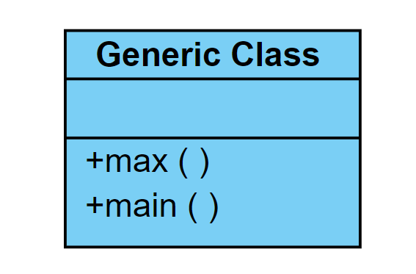

**PROGRAM:**

/**

* Program to create Generic Function

* created by Akhshy Ganesh

* gmail : akhshyganeshb@gmail.com

*/

**package** GenericFunction;

**public** **class** GenericElements {

**public** **static** <T **extends** Comparable<T>> T max (T[] element)

{ T m;

m=element[0];

**for**(T e:element)

{

**if**(e.compareTo(m)>0)

m=e;

}

**return** m;

}

**public** **static** **void** main(String[] args) {

Integer[] intArray= {1,2,3,4,5};

Integer intMax;

Double[] doubleArray= {1.1,2.2,3.3,4.4};

Double doubleMax;

String[] strArray= {"apple","orange","banana","welcome"};

String strMax;

intMax=*max*(intArray);

System.***out***.println("Max integer: "+intMax);

doubleMax=*max*(doubleArray);

System.***out***.println("Max double: "+doubleMax);

strMax=*max*(strArray);

System.***out***.println("Max string: "+strMax);

}

}

**OUTPUT:**

Max integer: 5

Max double: 4.4

Max String: Welcome

**RESULT:**

Thus a java console application that finds the maximum value from given type of elements is verified.